**WEEKLY REPORY**

 **“ PHARMACY MANAGEMENT SYSTEM“**

**BY:**

**ABDULATI K.S JAHBEL - 1841720223**

**TROY NUGROHO MUKTI - 1841720069**



**STUDY PROGRAM INFORMATICS ENGINEERING**

**DEPARTMENT INFORMATION TECHNOLOGY**

**STATE POLYTECHNIC OF MALANG**

**2021**

**Weekly Report**

This week our team try to finishing the creating and implementing database for our pharmacy management system. In this database we use 6 entities :

1. Admin

This entities is used by admin to login, Admin entities has 3 attribute :

1. Id(Primary Key)
2. Username
3. Password
4. Category

This entities used to classify medicine categories, Category has 3 attribute :

1. Category_id(Primary Key)
2. Category_name
3. Description
4. Customer

This entities used to make record of customer that buy the medicines, Customer has 4 attribute :

1. Customer_id(Primary Key)
2. Name
3. Address
4. Phone
5. Medicines

This entities used to take record of all medicine in the store, Medicines has 8 attribute:

1. Medicine_id(Primary Key)
2. Name
3. Type_id(Foreign Key from Type)
4. Category_id(Foreign Key from Category)
5. Expired_date
6. Price
7. Stock
8. Description
9. Purchase

This entities used to take record of all purchased medicine in the store, Purchase has 6 attribute :

1. Purchase_id(Primary Key)
2. Medicine_id(Foreign Key from Medicine)
3. Admin_id(Foreign Key from admin)
4. Customer_id(Foreign Key from Customer)
5. Amount
6. Purchase_date
7. Type

This entities used to classify medicine categories, Category has 2 attribute :

1. Type_id(Primary Key)
2. Type_name

**Screenshoots**



Admin Table

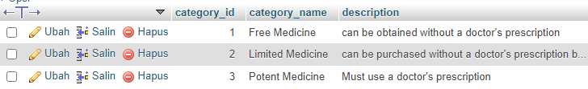

Category Table

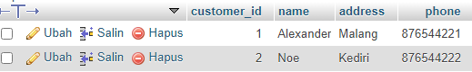

Customer Table

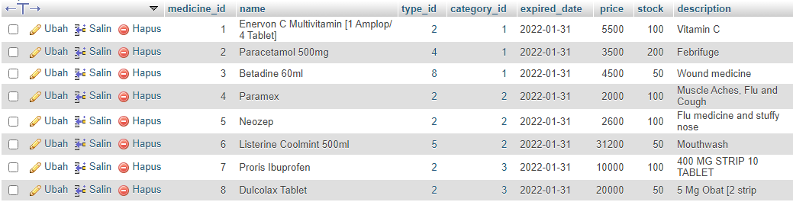

Maedicine Table

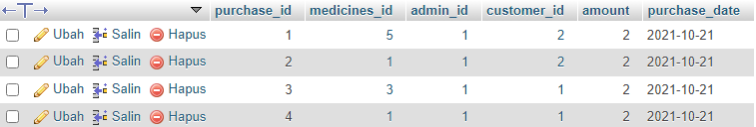

Purchased Table

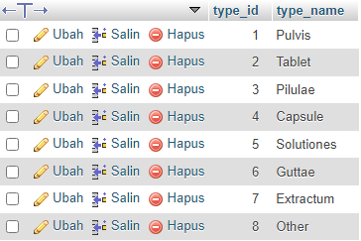

Type Table